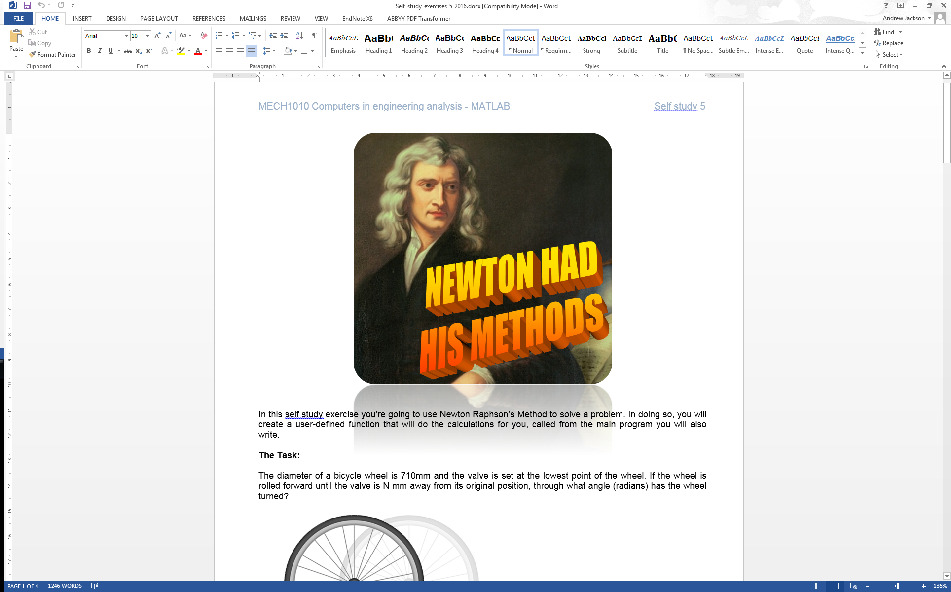

Self Study 5- Newton Had His Methods

# Introduction

In this self study exercise you’re going to use Newton Raphson’s Method to solve a problem. In doing so, you will create a user-defined function that will do the calculations for you, called from the main program you will also write.

# The Scenario

The diameter of a bicycle wheel is 710mm and the valve is set at the lowest point of the wheel. If the wheel is rolled forward until the valve is N mm away from its original position, through what angle (radians) has the wheel turned?

Assuming the valve is 300mm from the centre of the wheel the equation to be solved is:

$$355x-300 \sin{x}=N$$

where $x$ is the angle turned through in radians.

## A Brief Overview of Newton’s Method

Newton’s Method or Newton Raphson Method is an iterative solver for finding the solution to an equation. A first guess is used that then produces a better approximation, the process is repeated and a new better approximation is derived and so on... We use it when we can’t explicitly find the solution to an equation. The method is explained below in figure 1. From this we following equation:

$$x_{new}=x_{0}-\frac{y_{0}}{\left(\frac{dy}{dx}\right)}$$

$$x_{new}=x_{0}-\frac{f\left(x_{0}\right)}{f'\left(x_{0}\right)}$$

This can then be repeated replacing $x_{0}$ with $x_{new}$ and a new $x_{new}$ calculated. The solution can be found when $x_{new}$ has converged on the solution, usually defined as when the value of $x_{new}$ remains the same between iterations to a specific level of accuracy e.g. the same to 6 decimal places.

# Instructions

Figure :Newton's Method derivation

Our function is:

$$f\left(x\right)=355x -300\sin{x}-N=0$$

We want to solve it when $N=100$ but so that we have more versatility we will be using a user defined function for this task and N will be the second input argument and the first will be x0. Your program will output a value of x for when f(x) = 0 to 6 decimal place.

The following variables will be used within your code:

x0  
n  
xold  
xnew  
change  
solution  
convergence  
step  
x_final

1. Now open the editor and save a new .m file as bike_problem.m. As always, you should place a comment describing the function of the program at the start. Also clear the command window and workspace programatically.

2. The next step is to initialise some variables. First create two row vectors, initialised to 15 values of zero, one called convergence and one called solution. You can use the zeros function for this (QG 1.4).

3. Now create initialise some scalar values. x0, step, change and n and set them to 5, 1, 100 and 100 respectively. Place the value of x0 in the first column of row vector solution.

4. Create a variable called xold and set it to x0.

5. Now you are going to use a while loop that will run until our convergence criteria is met. The while loop will include a call to our user-defined function that we will create shortly. Your while loop should run until the difference between xold and xnew is less than 0.000001. We will assign the difference to the variable change which we initialised to a value of 100 in step 3. Write the start of the while loop with a conditional statement including the variable change. (See QG 7)

6. Inside your while loop, increment stepby 1.

7. Now you are going to create your user-defined function. This function will be passed xold and the value n and will return a value for xnew, that is next best guess at a solution. Open a new script file by going to File -> New -> Script. Save this new file as newton_method.m in your working directory.

8. To define this file as a function the first line of code should be of the format:

function output = function_name(inputs)

In our case, the output will be a variable xnew, our function_name is newton_method and our inputs are xold and n giving: function xnew = newton_method(xold, n). Below the first line, add a comment that will form the part of the help information of the function.

9. Within this function file you should implement the following equation:

$$x_{new}=x_{0}-\frac{f\left(x_{0}\right)}{f'\left(x_{0}\right)}$$

where $x_{0}$ is xold, and $f\left(x_{0}\right)$ is 355*xold-300*sin(xold)-N. You can work out what $f'\left(x_{0}\right)$ will be by finding the derivative of $f\left(x_{0}\right)$. The user-defined function will return the value xnew*.* Type the word endat the bottom of the function file to define the end of the function*.* Save newton_method.m.

10. Go back to bike_problem.m. Now call the newton_method.m function from within the while loop you defined. The script used to call it should look like the first line of code in the function file (see step 8), without the word function.

11. Still within the while loop we want to calculate change. To do this we want the absolute difference between xnew and xold. Remember the abs function you used in self-study 1.

12. Place the value changein to the vector convergenceyou defined in step 2 at the index step. (See QG 2.13)

13. Place the value xnewinto the vector solutiondefined in step 2 at the position step.

14. Assign the value of xnew to the variable xold and end the while loop. This loop should now iterate, calling the newton_method function each time and will stop when changeis less than 0.000001. After loop has ended, xnewwill contain our solution.

15. Now we want to reduce the size of the vectors convergence and solution so they just contain the data from index 1 up to the value at index step.

16. Now to visualise some of the data. We want to show how our guess converged to the correct answer. Plot solution against a vector called iteration you can create, the latter should run from 0 to step-1.

Now open a figure window. Use figure(1)in your code. This will open a figure window and set figure number 1 to the active figure. Produce a plot plotting the solution against iteration. Label the plot correctly using:

xlabel('label')

ylabel('label')

17. Finally set create a variable x_final that contains the last value in solution or xnew. Save both .m files and run in MATLAB. Once happy, submit via scriptcheck following the instructions below.

18. To convert your code into one that ScriptCheck can run (because you can’t submit multiple files) you will need to copy and paste your user defined functions into the bottom of your main code so that newton method will become a local function. To do this, copy and paste your bike_problem.m file into the text box on scriptcheck. Below this type the word end. Next copy your function file newton_method.m and paste this on the bottom of the file after the word end. The general structure should look like this:

Your bike_problem.m code

end

Your newton_method.m code.

Submit your code and hopefully get 100%!